CIS 572 Object Oriented System Design

**ChocoAn Software Analysis Specification**

Team : She-Wolverines

Submitted to : Prof. Thomas Steiner



Team Members

Tejaswi Dasyam

Vaishali Jain

Khushmeet Kaur

Mohanapriya Kottan Rajaraman

Kopal Shinde

**Table of Contents**

**1.0 Introduction** **3**

1.1 Goals and objectives 3

1.2 Statement of scope 3

1.3 Software context 4

1.4 Major constraints 4

**2.0 Usage scenario** **5**

2.1 User profiles 5

2.2 Major software functionality 5

2.3 Special usage considerations 5

**3.0 Data Model and Description** **5**

3.1 Data Description 5

3.1.1 Build Entity-Relationship Diagram 7

3.1.2 Data Flow Diagram 7

3.1.3 Object Relationships 7

3.1.4 Complete data model 8

3.1.5 Data dictionary 8

**4.0 Functional Model and Description** **8**

4.1 Use cases 9

4.2 Software Interface Description 9

4.2.1 External machine interfaces 9

4.2.2 External system interfaces 9

4.2.3 Human interface 9

4.3 Sequence Diagrams 9

4.4 Communication Diagrams 9

**5.0 Behavioral Model and Description** **9**

5.1 Description for software behavior 9

5.2 State Transition Diagrams 10

**6.0 Restrictions, Limitations, and Constraints** **10**

**7.0 Validation Criteria** **10**

7.1 Classes of tests/Test Strategy 10

7.2 Expected software response 11

7.3 Performance bounds 12

**8.0 Appendices** **12**

8.1 System traceability matrix 12

8.2 Product Strategies 12

8.3 Analysis metrics to be used 12

8.4 Supplementary information 12

# 

# **1.0 Introduction**

Chocoholics Anonymous is an organization that helps individuals who are addicted to chocolates. This organization employs professional health care providers like, dietitians, internists and exercise specialists. All professionals work together to help the people facing addiction.

ChocoAn organization has an interactive terminal through which the provider interacts with the whole software system to check for the services and the related fees. The Software system runs batch jobs every friday midnight to generate various reports. The Acme Accounting Service runs the batch jobs everyday at 9 pm to update the member status.

### **1.1 Goals and objectives**

The objective of this software project is to help the organization to manage the members and service providers and provider various functionalities to improve the performance. The Goals and objectives are:

* Enhance the performance.
* Enhance member satisfaction.
* Fast services.
* Quick payments.
* Quick report gene

### **1.2 Statement of scope**

The software is intended for the use of members, providers and operators. It has an interface that has inputs and outputs, and processing functionality.

**Inputs:**

* Member details.
* Service Request.
* Member card details.

**Outputs:**

* Generate bills.
* Generate reports.
* Member Status.

**Functionality:**

* Storing member details.
* Storing provider details.
* Update member details.
* Update provider details.
* Generate Bills.
* Generate reports.
* Manage payments.

### **1.3 Software context**

The purpose of this software is to enhance the efficiency in providing services to the members and managing the payments and reports. The software is expected to address the problems like:

* Delay in providing service.
* Payment issues.
* Report generations.

### **1.4 Major constraints**

**1.4.1 Performance/Behavior constraints**

**Functional Constraints:**

* Information integrity is severely challenged if the data is not up to date.
* Optimization process is highly dependent on the manual intervention.

**Non Functional constraints:**

* Rapid response time, less than 5 seconds
* Software usability is 24x7; any downtime can have a high impact on the business.

**1.4.2 Management Constraints**

* Faster service providing is crucial to organization success.
* IT staff to work on the weekend for production launch.

**1.4.3 Technical Constraints**

* System must utilize real time data and batch process must run, as new information is acquired any lag can interrupt the information flow.

# **2.0 Usage scenario**

This section provides a usage scenario for the software.

### **2.1 User profiles**

Below are the profiles of all user categories :

|  |  |
| --- | --- |
| **User Profile** | **Description** |
| Manager | A chocoAn Employee who acts as a manager to the company. Manager has special permission to request the reports on adhoc basis and also gets the summary report weekly in his email. |
| Operator | A chocoAn Employee responsible for adding, updating and deleting Member and Provider Profile. |
| Provider | A provider is the health care professional who works for the ChocoAn organization to provide healthcare services to active members of ChocoAn organization.Provider submits the record of the services provided and get a weekly report stating the same.Provider also gets payment on per week basis depending on the number of services provided. |
| Member | A person who is registered with ChocoAn organization to avail healthcare services. Members uses the chocoAn interface to pay their monthly fees and get weekly reports via email. |

### **2.2 Major software functionality**

List of major software functionalities :

1. Time Triggers Report generation for all three reports ( Provider, Member and Summary) every friday midnight.
2. Manager requests the reports on demand.
3. ChocAn Operator Add, Update and Delete Member and Provider information.
4. Member Pay his/her monthly fees.
5. Update member status based on the payment validation done by Acme Accounting Services(AAS)
6. Process providers weekly payments via EFT transfer.
7. Provider requests for provider directory
8. Provider submits service record indicating the service details.

### **2.3 Special usage considerations**

Special requirements associated with the use of the software are presented below :

Input:

* Member’s detail
* Provider’s detail
* Provider’s service detail

Output:

* Provider Report
* Member Report
* Summary Report
* Provider Directory

External Interaction:

* AAS to validate member payment and update member status
* EFT to initiate provider payments

# **3.0 Data Model and Description**

### **3.1 Data Description**

**Member** : A person who is addicted to chocolate and has joined ChocAn to benefit from the services provided.

Member Number : A 9-digit number that uniquely identifies a ChocAn member.

Member Status : The status of a member may be Active (the member is up to date with payments and entitled to consultations) or Suspended (the member has not paid fees for at least a month and is not entitled to consultations).

**Provider** : A health-care professional who provides services to ChocAn members. Before providing a service, the provider can verify that the member has a valid membership card, and is not suspended. After providing a service to a member, the provider bills ChocAn by submitting a claim.

**Provider Number :** A 9-digit number that uniquely identifies a ChocAn provider.

Provider Type : The type of provider, namely dietician, internist or exercise specialist.

Provider Directory : An alphabetically ordered list of service names and corresponding service codes and fees.

**Service :** A classification of a treatment, consultation or session with a provider. Example, an aerobic exercise session, a clinical session with a Dietitian, or a consultation session with internist.

Service Code : A 6-digit code that uniquely identifies a service

**Manager :** A member of the staff of ChocAn, in a management position, who requires information about the services provided to members during a particular week, as well as the fees to be paid to the providers.

**Operator :** A member of the staff of ChocAn who has the role of maintaining the information about members and providers, i.e. adding a new member or provider, updating details and deleting a member or provider who resigns.

**EFT :** Electronic Funds Transfer - A transaction in which an amount of money is transferred from one bank account to another. Data to be used to transfer funds electronically from the ChocAn bank account to the providers’ bank account

**AAS :** Acme Accounting Services - A company responsible for financial procedures such as recording payments of membership fees, suspending members whose fees are overdue, and reinstating suspended members who have now paid what is owed.

#### **3.1.1 Build Entity-Relationship Diagram**

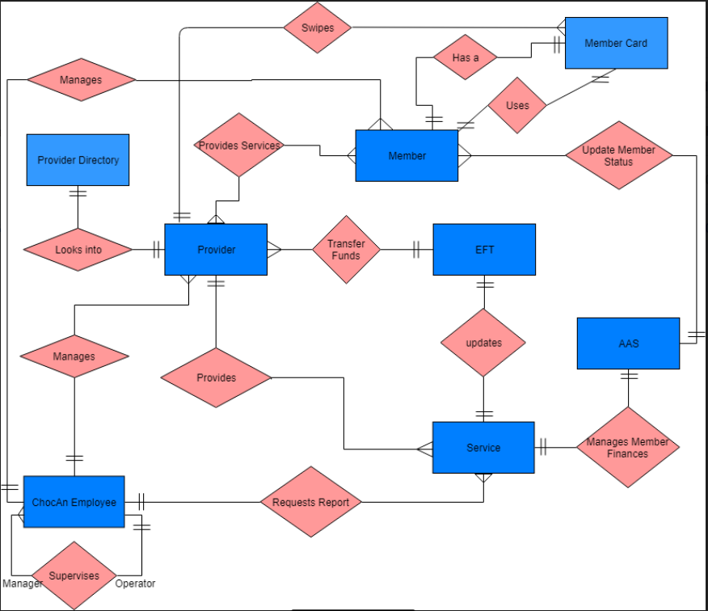

#### **3.1.2 Data Flow Diagram**

All DFD’s including Context Diagram are placed in DFD folder

#### **3.1.3 Object Relationships**

|  |  |
| --- | --- |
| **Class** : Member Entity |  |
| **Responsibility** | **Collaborators** |
| Member details like member name, member number, member status, make payment | Manage Member Control |

|  |  |
| --- | --- |
| **Class** : Manage Member Control |  |
| **Responsibility** | **Collaborators** |
| Add/update/delete Members | Member Entity |

|  |  |
| --- | --- |
| **Class** : Provider Entity |  |
| **Responsibility** | **Collaborators** |
| Provider details like provider name, provider number, provider status,provider bank account | Manage Provider Control |

|  |  |
| --- | --- |
| **Class** : Manage Provider Control |  |
| **Responsibility** | **Collaborators** |
| Add/update/delete Providers | Provider Entity |

|  |  |
| --- | --- |
| **Class** : Service Entity |  |
| **Responsibility** | **Collaborators** |
| Service code, Fees, Name. | Provide Service Control |

|  |  |
| --- | --- |
| **Class** : Provide Service Control |  |
| **Responsibility** | **Collaborators** |
| Get Provider directory, Provide Services to Members | Service Entity, Member Entity,  Provider Entity |

|  |  |
| --- | --- |
| **Class** : ChocAn Control |  |
| **Responsibility** | **Collaborators** |
| Add Service Details, Update Member Status. Sends Report every midnight to Member, Provider and Manager | Service Entity, Member Entity, Manager Entity, Provider Entity |

|  |  |
| --- | --- |
| **Class** : Manager Entity |  |
| **Responsibility** | **Collaborators** |
| Requests the Reports and Receives it | Service Entity, ChocAn Controller |

#### **3.1.4 Complete data model**

Robustness Class Diagram

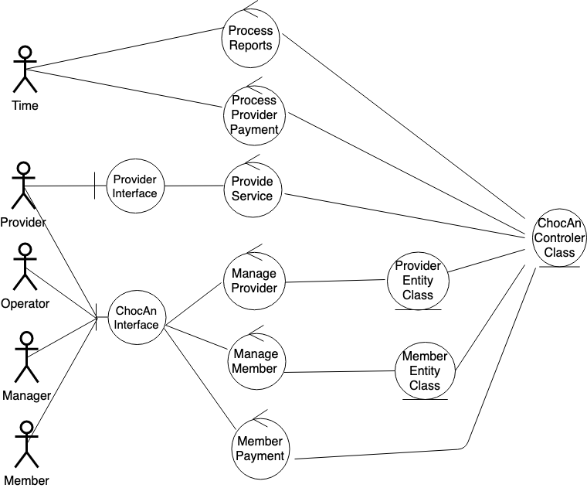

#### **3.1.5 Data dictionary**

[Glossary](https://docs.google.com/document/d/1CWlIp034tdGI0SFZBdnR03Mp4qelBj0cu19pxTODz9s/edit#heading=h.47iamcvesfwg)

# **4.0 Functional Model and Description**

### **4.1 Use cases**

Below is the Link for Use case Summary and Individual Use cases.

The use case summary provides an overview of all the use cases and their description, all the actors interacting with the system. Complete details about the use case summary can be obtained in the use case summary document. Please refer to use case summary link.

Each Individual use case document provides the functional description of the use case, actors interacting, constraints, happy path, exception flow if any and other additional details. Please refer to each Link for more details about the use case documents.

**Use case Summary:**

[Use Case Summary](https://docs.google.com/document/d/15XQmaF7X1sEhGVFtkjEMKH_WlW8GPHA3lpCdNjRRDdE/edit)

**Use case 1- Manage ~~Registration~~ Member:**

[Manage Member](https://docs.google.com/document/d/1HuuiE7o1EBV8ugt4rViox9uOCa43eWewJgUaV5uxfIo/edit)

**Use case 2- Provider Payment:**

[Provider Payment](https://docs.google.com/document/d/1Kb4dlPyzlGUcJ6H5jT72I9gg3UVB464710LYca7zO70/edit)

**Use case 3- Member Payment:**

[Member Payment](https://docs.google.com/document/d/1v2Mzprn-tg3K1B_R6NHFBhdVn2_CV2tuQn7hR72HC0Y/edit)

**Use case 4- Report Extraction:**

[Report Extraction](https://docs.google.com/document/d/1nmTJoi6p38gOxFlpkqJb88QrO1h72vWTTEKT9yNebJI/edit)

**Use case 5- ~~Provide~~ Track Service:**

[Track Service](https://drive.google.com/open?id=1HNRL59JdS_gAKmsP9VF4_BtN7GSMB9bnjfihwwGxI8I)

**Use case 6- Manage Provider:**

[Mange Provider](https://docs.google.com/document/d/1bfM3MFCcNzS-24atCD1A6eBMMEJjf5S9/edit)

### **4.2 Software Interface Description**

#### **4.2.1 External machine interfaces**

The ChocAn terminal is connected to the internet.Packets flow to and fro between internet and ChocAn Terminal. ChocAn is also connected to the keyboard. ChocAn currently uses the keyboard for inputting data into the system.

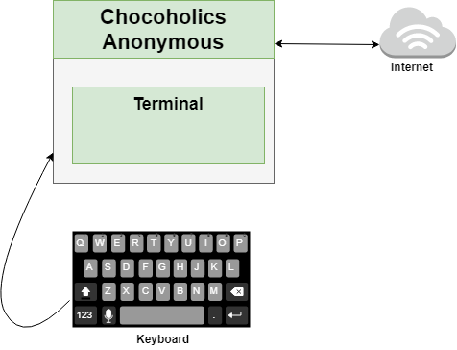

#### **4.2.2 External system interfaces**

EFT and AAS are two systems that are outside the ChocAn and will interact with ChocAn system for Funds transfer and membership payment and status updates respectively.

EFT - Electronic Funds Transfer. Provider payment will be deposited into the provider’s bank account through EFT.

AAS - Acme Accounting Services will process the payments of membership fees and membership status. If the member does not pay the membership fee and it is overdue it will suspend the member and change the status of the member to suspended in ChocAn Datacenter.

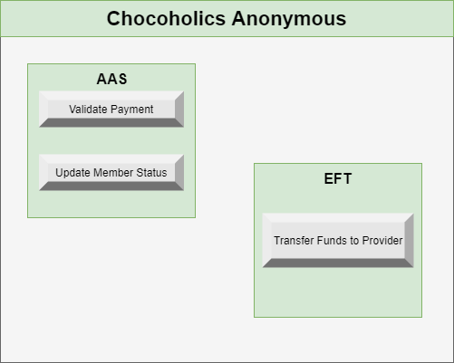

#### **4.2.3 Human interface**

The ChocAn interface where the operator, provider is interacting with the terminal is presented below

**4.2.3.1 User screen interface layouts**

**Main Screen (Use case 1 - Manage ~~Registration~~ Member, Use case 6 - Manage Provider)**- The operator can Add/ Update/ Delete a Member/ Provider

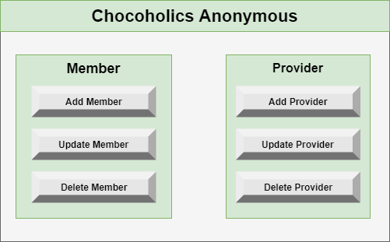

**Main Screen**

**Provide Service (Use case 5 - ~~provide~~ track service)**- Provider can verify the member and also verify the service code from the provider directory and then provide service. The provider will enter the service details for the member consultation and submit it to save the details in ChocAn Datacenter.

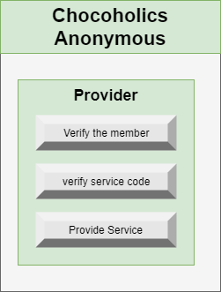

**Provider Screen**

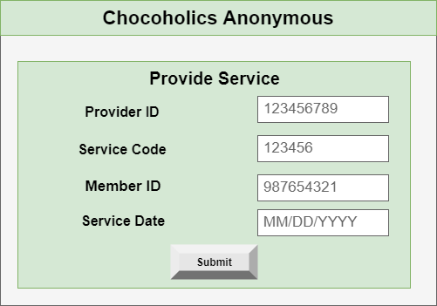

**Provide Service**

**Member Payment (Use case 3 - member payment)-** Member will have to make a monthly payment to ChocAn to receive unlimited services. Providers provide services to the members.

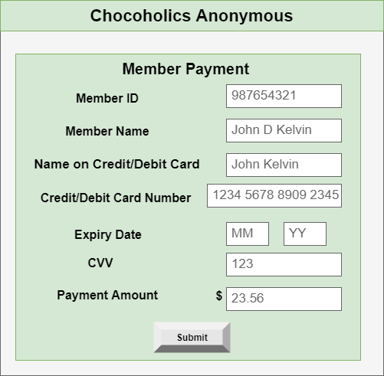

**Member Payment**

**4.2.3.2 Report layouts**

**Provider Report:** Manager can view the provider report which includes the details - provider name, provider ID, address and other details that are presented in the report below. From this report, the manager can get information about which provides service to which member and also the type of service and service cost. It also provides the total number consultations by individual provider and the total fee per week that has to be paid to the provider by ChocAn.

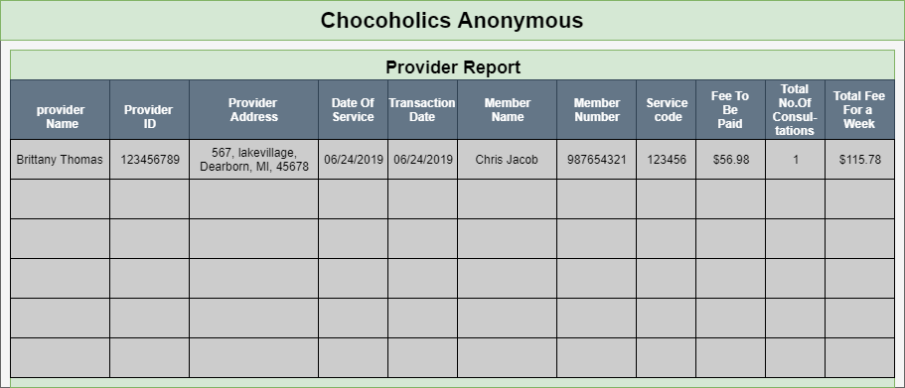

**Provider Report**

**Member Report**: Manager can view the member report which includes details - Member name, Member ID, Address, Date of service, Provider name, service name. From this Manager can get information about which member took services from which provider and also the date service was taken by the member.

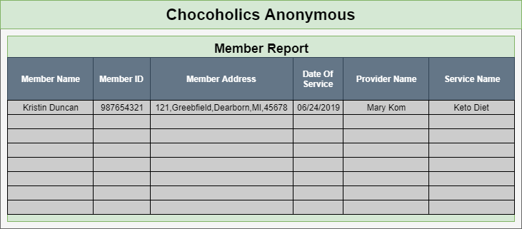

**Member Report**

**Summary Report**: Manager can view the summary report which includes details- provider name, provider id, no of consultations and total fees. From this report, the manager can get details about the cost that needs to be paid to the individual provider by ChocAn and Also the Overall Cost for all consultations.

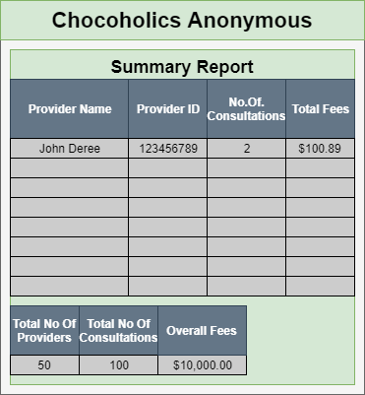

**Summary Report**

### **4.3 Sequence Diagrams**

Sequence diagrams for each individual use cases are listed below

**Use case 1- Manage ~~Registration~~ Member:**

**1.1. Add Member -**

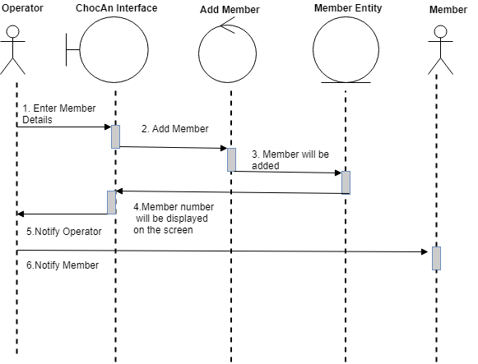

**1.1. Add Member**

**~~1.2. Add Provider~~ -**

**~~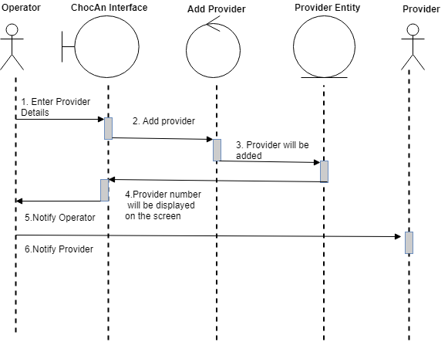~~**

**~~1.2. Add Provider~~**

**1.~~3~~ 2. - Delete Member -**

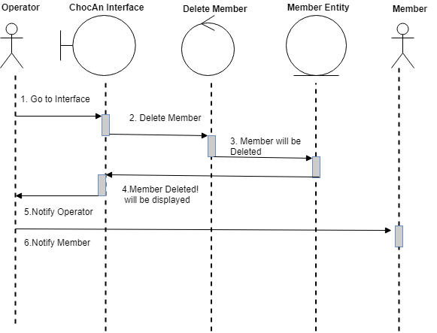

**1.~~3~~ 2. Delete Member**

**~~1.4. Delete Provider -~~**

**~~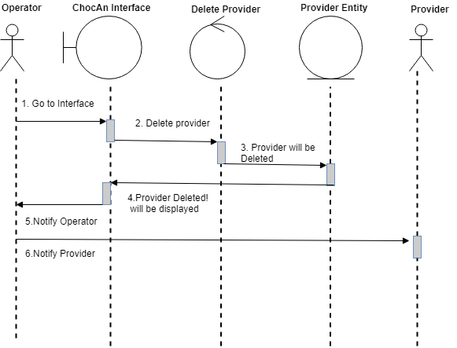~~**

**~~1.4. Delete Provider~~**

**1.~~5~~ 3. Update Member -**

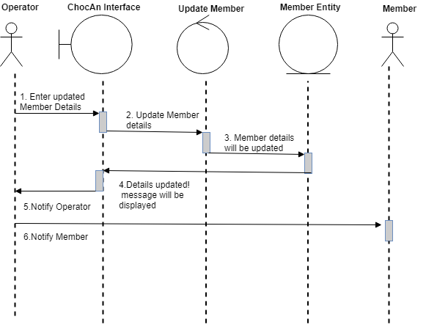

**1.~~5~~ 3. Update Member**

**~~1.6. Update Provider -~~**

**~~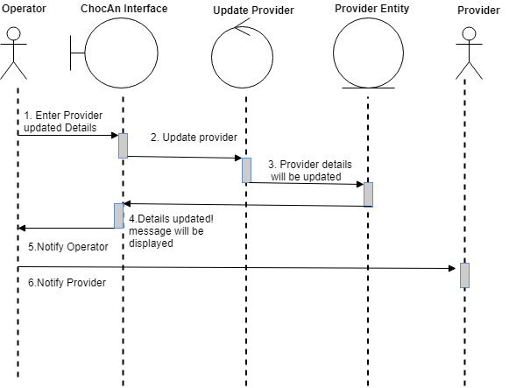~~**

**~~1.6. Update Provider~~**

**Use case 2- Provider Payment:**

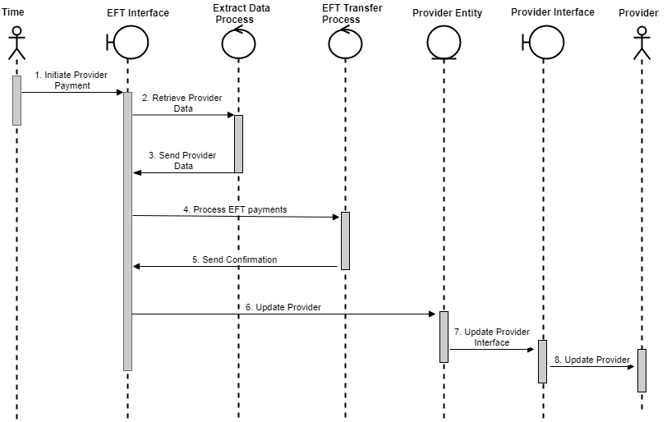

**Provider Payment**

**Use case 3- Member Payment:**

**3.1. Member Payment -part -1**

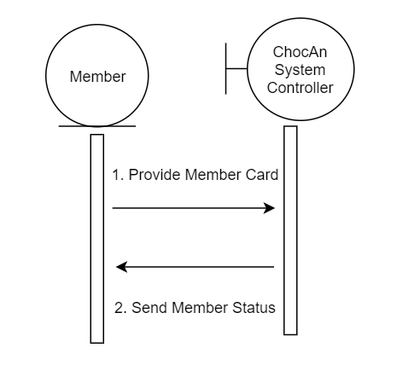

**3.1. Member Payment -1**

**3.2. Member Payment - Part 2**

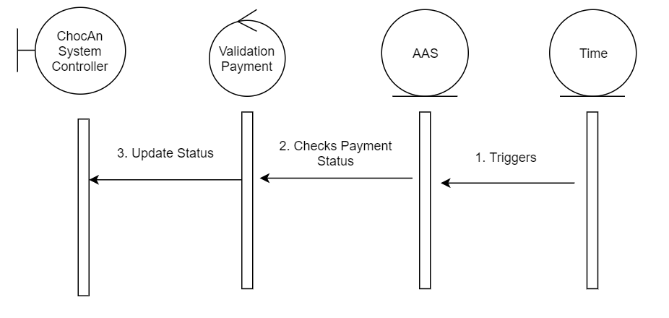

**3.2. Member Payment - 2**

**Use case 4- Report Extraction:**

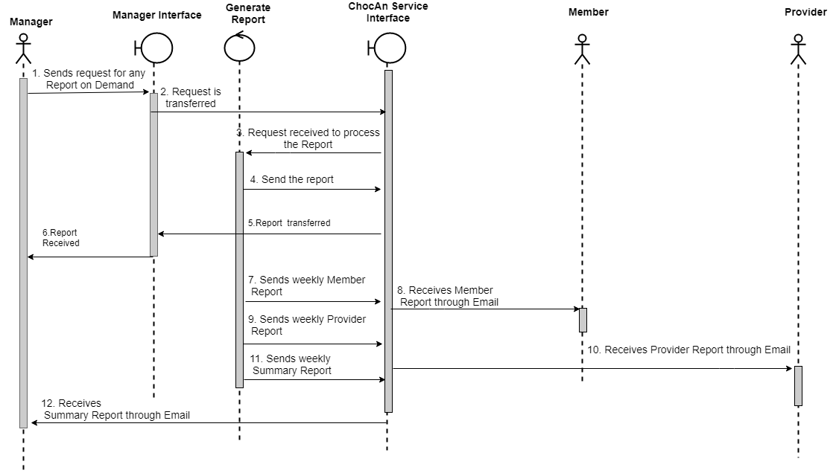

**Report Extraction**

**Use case 5- ~~Provide~~ Track Service:**

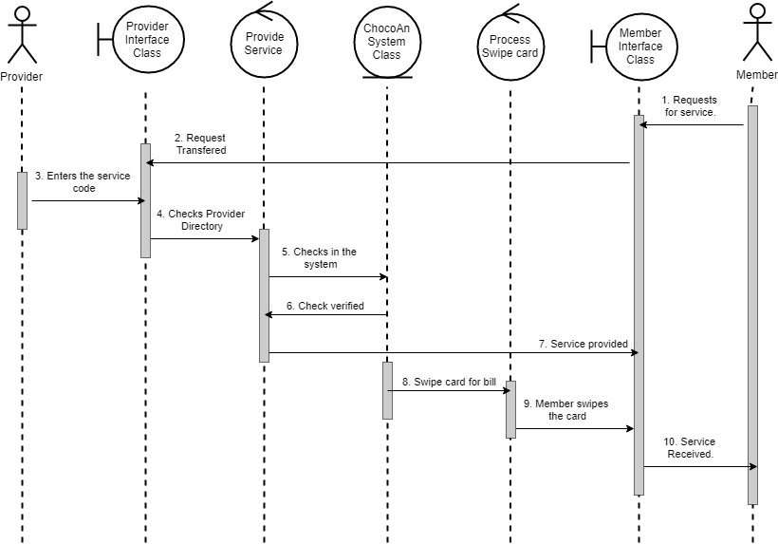

**~~Provide~~ Track Service**

**Use Case 6- Manage Provider:**

**6.1. Add Provider -**



**6.1. Add Provider**

**6.2. Delete Provider -**



**6.2. Delete Provider**

**6.3. Update Provider -**



**6.3. Update Provider**

### **4.4 Communication Diagrams**

For Each Individual Use cases, Communication diagrams are presented below

**Use case 1 - Manage ~~Registration~~ Member:**

**1.1. Add Member**

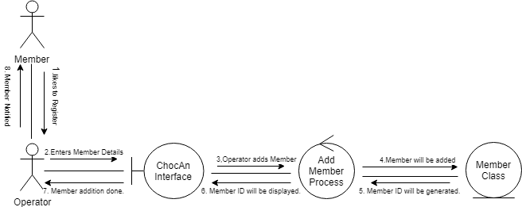

**1.1 Add Member**

**~~1.2. Add Provider~~**

**~~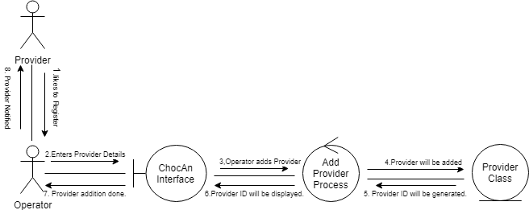~~**

**~~1.2. Add Provider~~**

**1.~~3~~ 2. Delete Member**

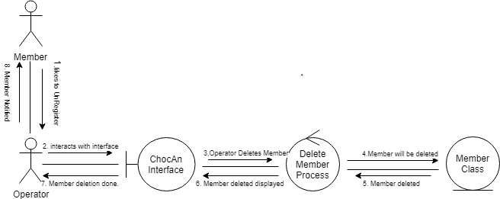

**1.~~3~~ 2. Delete Member**

**~~1.4. Delete Provider~~**

**~~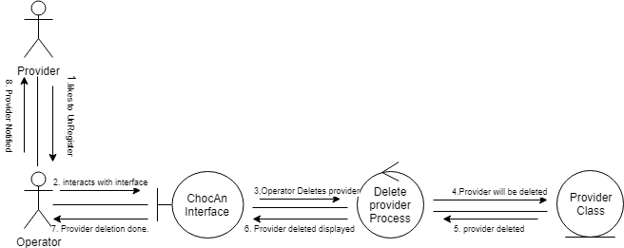~~**

**~~1.4. Delete Provider~~**

**1.~~5~~ 3. Update Member**

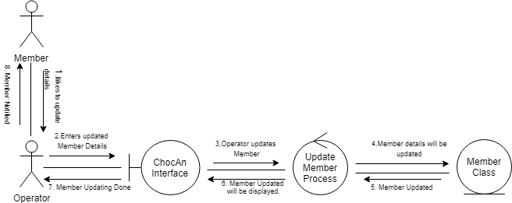

**1.~~5~~ 3. Update Member**

**~~1.6. Update Provider~~**

**~~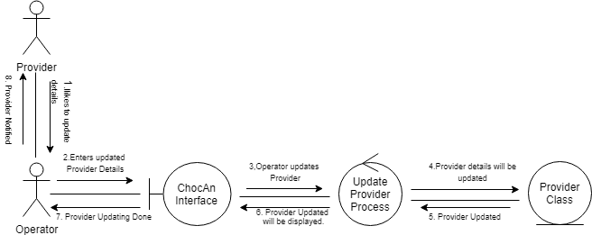~~**

**~~1.6. Update Provider~~**

**Use Case 2 - Provider Payment**

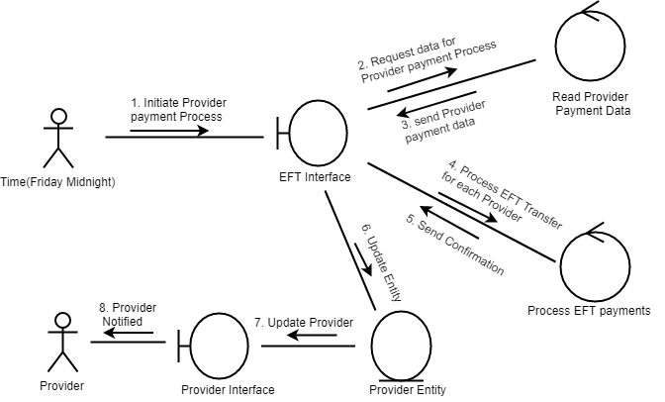

**Provider Payment**

**Use Case 3 - Member Payment**

**3.1. Member Payment -Part 1**

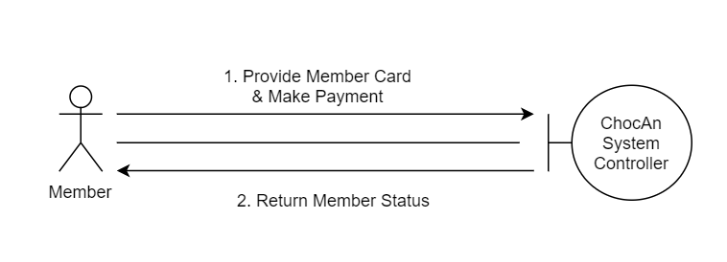

**3.1. Member Payment -Part 1**

**3.2. Member Payment -Part 2**

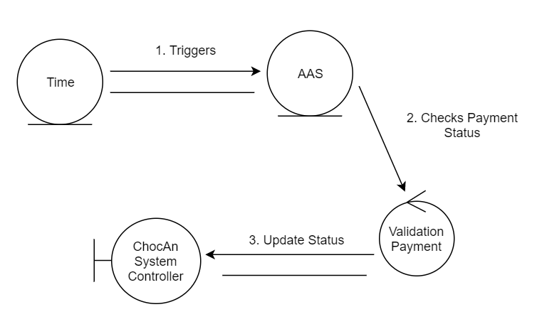

**3.2. Member Payment -part 2**

**Use Case 4 - Report Extraction**

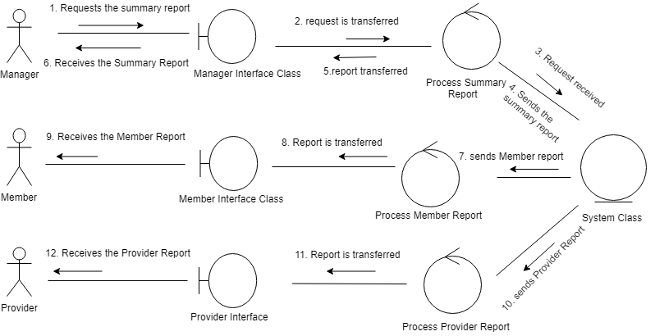

**Report Extraction**

**Use Case 5 - ~~Provide~~ Track Service**

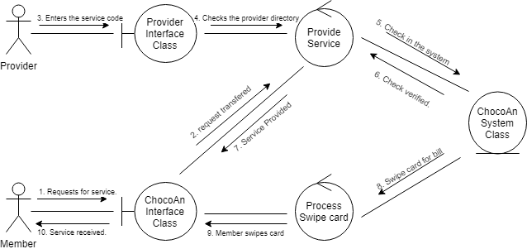

**~~Provide~~ Track Service**

**Use Case 6 - Manage Provider**

**6.1. Add Provider**



**6.1. Add Provider**

**6.2. Delete Provider**



**6.2. Delete Provider**

**6.3. Update Provider**



**6.3. Update Provider**

### 

# **5.0 Behavioral Model and Description**

The change of state done on or by the entity represents the behavior.

### **5.1 Description for software behavior**

**5.1.1 Events**

Below are the events listed for ChocAn Data System:

* Member registers with ChocAn System.
* Member makes payment.
* Provider provides services.
* Time triggers the generation of different reports.
* Operator updates the status.
* Manager requests for the reports.

**5.1.2 States**

Below are the state changes which occur as a result of an event:

* Member gets the membership card and registered in the system.
* Member status gets updated in the system.
* Member receives the services provided.
* Reports are sent as an email to the members, providers and manager.
* Member gets deleted, added or updated in the chocAn system.
* The system generated report is received by Manager in email.

### **5.2 State Transition Diagrams**

**Use case 1 -**  **Manage ~~Registration~~ Member**

**1.1 Member State**

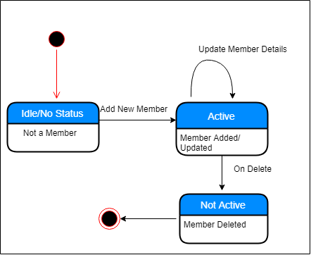

**Member State**

**~~1.2 Provider State~~**

**~~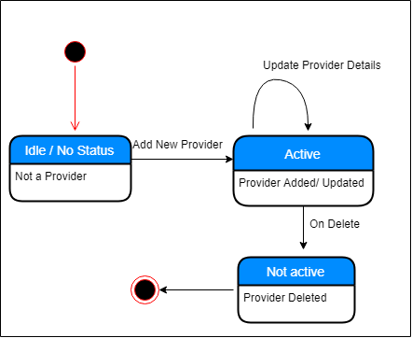~~**

**~~Provider State~~**

**Use Case 2 - Provider Payment**

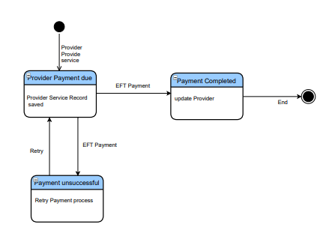

**Provider Payment**

**Use Case 3 - Member Payment**

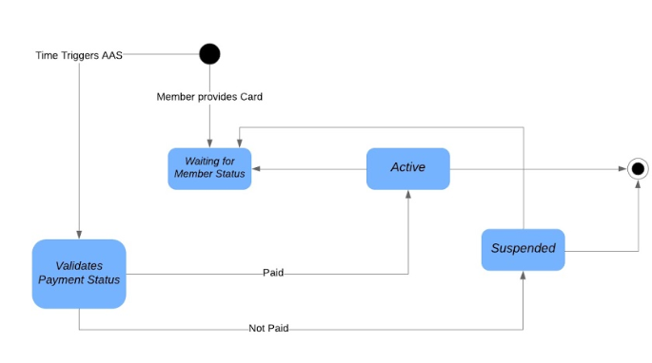

**Member Payment**

**Use Case 4 - Extract Report**

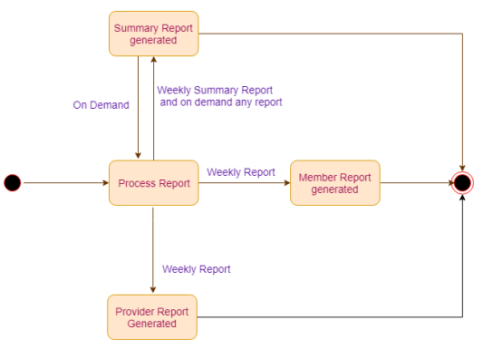

**Extract Report**

**Use Case 5 - ~~Provide~~ Track Services**

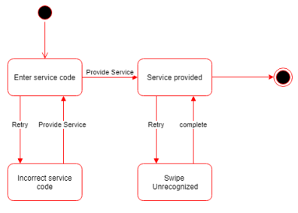

**~~Provide~~ Track Services**

**Use Case 6 - Manage Provider**

**6.1. Provider State**



**Provider State**

# **6.0 Restrictions, Limitations, and Constraints**

* Manager is having access to view any report generated by the system.
* A member will have only one member Id , i.e. a member can not register twice
* Only operator can add, update or delete the Member and Provider.

# **7.0 Validation Criteria**

The approach to software validation is described.

### **7.1 Classes of tests/Test Strategy**

1. **Member Information Validation:**
   1. When a member makes service request, operator checks for the details in the system.
   2. If the request is made for the first time, then the member has to be approved by the manager.
   3. Member is not added to the system until operator gets approval from the manager.
2. **Validate New employee:**
   1. Every Employee has is assigned with a role. When a new employee is added to the system, then the system will validate their role.
   2. If role doesn’t exist in the system, then the system will not allow to add the employee.
3. **Validate Reports:**
   1. Select the data for which the reports are to be generated
   2. If incorrect data is selected, an exception has to be raised.
   3. If there is no information available in the selected data fields, then report is not generated.
4. **Validate Bill :**
   1. Check if service status is complete – Bill is generated to member.
   2. Service Status is incomplete – Save the information, but do not generate bill
   3. Check if prices are correct in the bill – If the entered values are not correct, cancel the existing bill and generate a new one.
5. **Validate Member Status:**
   1. Check if member status is active or suspended.
   2. Member Status is active – provide the service requested.
   3. Member status is suspended – member should pay the monthly membership fee to receive the services.
6. **Validate Member Card:**
   1. Check if member card is active or expired.
   2. Member Status is active – provide the service requested.
   3. Member status is expired – member should renew the card to receive the services.
7. **Validate Provider Payment:**
   1. Provider payment is calculated from the provider directory.
   2. Provider can verify the amount by keeping a record in provider form..
   3. Receives the payment equivalent to the services provided.

### **7.2 Expected software response**

**Member Information Validation:** A new member will be added to the database and can receive the services.

**Validate New employee:** A new employee can be provider, manager or operator. Based on the role, data will be added to the database and employee will perform the associated role.

**Validate Reports:** Reports are generated and sent to those who request them.

**Validate Bill :** Member receives the bill.

**Validate Member Status:** Status can be changed to active from suspended by paying membership fee.

**Validate Member Card:** Expired card can be renewed.

**Validate Provider Payment:** Provider receives the payment.

### **7.3 Performance bounds**

* + Response time should be fast when operator looks for the details in the system.
  + Any updates made to the data should reflect immediately.
  + The Search results should be displayed faster when operator looks for the existing member details.
  + Billing process should run timely, otherwise payment will be effected.
  + Reports should be generated quickly after the request.

# **8.0 Appendices**

Presents information that supplements the Requirements Specification

### **8.1 System traceability matrix**

[**Traceability Matrix**](https://drive.google.com/drive/folders/17zHlMqtVYjQwfLb4yJaBDBsqKiBOLesV)

### **8.2 Product Strategies**

The product is used internal to the company for better maintenance of the records and easy reporting in the form of weekly reports. This product will help the operators manage the member and provider details efficiently and also help the manager get the performance metrics easily and on demand. The UI will help employees to have interactive and efficient communication with the system.

### **8.3 Analysis metrics to be used**

None

### **8.4 Supplementary information**

None